BMS INSTITUTE OF TECHNOLOGY & MANAGEMENT

Yelahanka, Bengaluru – 560 064



Department of Computer Science and Engineering

Synopsis for the Project work

“Pressure Ulcer Prediction and Prevention”

Submitted By:

1. A Nitya Dyuthi 1BY18CS001

2. Khuswinder Singh 1BY18CS074

3. Likith S 1BY18CS081

4. Prakhyat 1BY18CS108

Under the Guidance of

Mrs. Durga Bhavani A

2021-2022

BMS INSTITUTE OF TECHNOLOGY, BANGALORE-560064



**Students Project Review and Assessment Committee**

**Intermediate Report-Phase II-Review 1**

| **Batch No:**  **15** | | **Guide Name:**  **Mrs. Durga Bhavani A** | | **Submission Date:**  **13-05-2022** |
| --- | --- | --- | --- | --- |
| **Project Title**    **Pressure Ulcer Prediction and Prevention** | | | | |
| **Sl No** | **USN** | | **Name** | |
| **1** | **1BY18CS001** | | **A Nitya Dyuthi** | |
| **2** | **1BY18CS074** | | **Khuswinder Singh** | |
| **3** | **1BY18CS081** | | **Likith S** | |
| **4** | **1BY18CS108** | | **Prakhyat** | |
| **Project Execution Place** | | | **In-house** | |
| **Project Category** | | | **Research and Societal** | |

**Signature of HoD Signature of the Guide SPARC**

**Chapter 1**

**Abstract**

Pressure ulcers (PU) or Decubitus ulcers (DU) are localized injuries to the skin or underlying tissue, usually over a bony prominence, as a result of unrelieved pressure. They are deep scars that can reach up to the bones and are extremely painful. They affect people that do not have much ambulation and are bound to a bed all day long. The proposed system includes predictive and preventive methods to solve the issue of bedsores. The predictive solution involves measuring pressure and moisture levels and taking corrective measures to prevent painful bedsores, and the preventive measure is to use a mattress to aid in redistributing pressure from a concentrated area. The mattress consists of a set of air pockets. The pressure in the air pockets surrounding the pressurized area is changed so that the pressure on said area of the body is reduced, thereby preventing bedsores.

Older people, whether staying at home, in hospitals, or in retirement homes, incur the risk of health symptoms and problems. Due to the advent of COVID-19, the number of cases where the patient is prescribed bed rest is soaring. Due to bony prominence, the common sites for DU include heels, shoulder blades, elbow, and coccyx/sacrum (gluteal). They are a common injury that mainly plagues elders and frail people, and is a major cause of concern in medical institutions. Current screening and prevention techniques for assessing risk for decubitus ulcer formation and repositioning patients every 1-3 hours are labor-intensive and can be subjective.

We have proposed a system using low-cost, disposable wireless, and unobtrusive fabric-based pressure sensors and hygrometer (to measure moisture levels on the skin) to continuously monitor the tissue status in at-risk areas already developed to detect the pressure and make the necessary adjustments to the bed to prevent the same.

**Chapter 2**

**System Analysis**

**2.1 Overall Process of the project**

The process of the system is as shown in the diagram below:

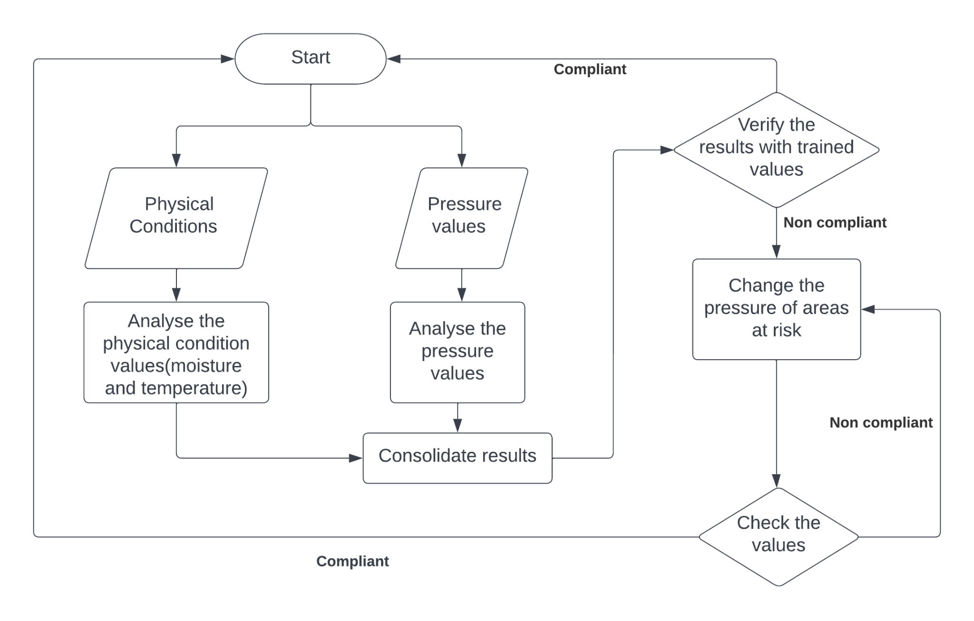

Fig Process Diagram

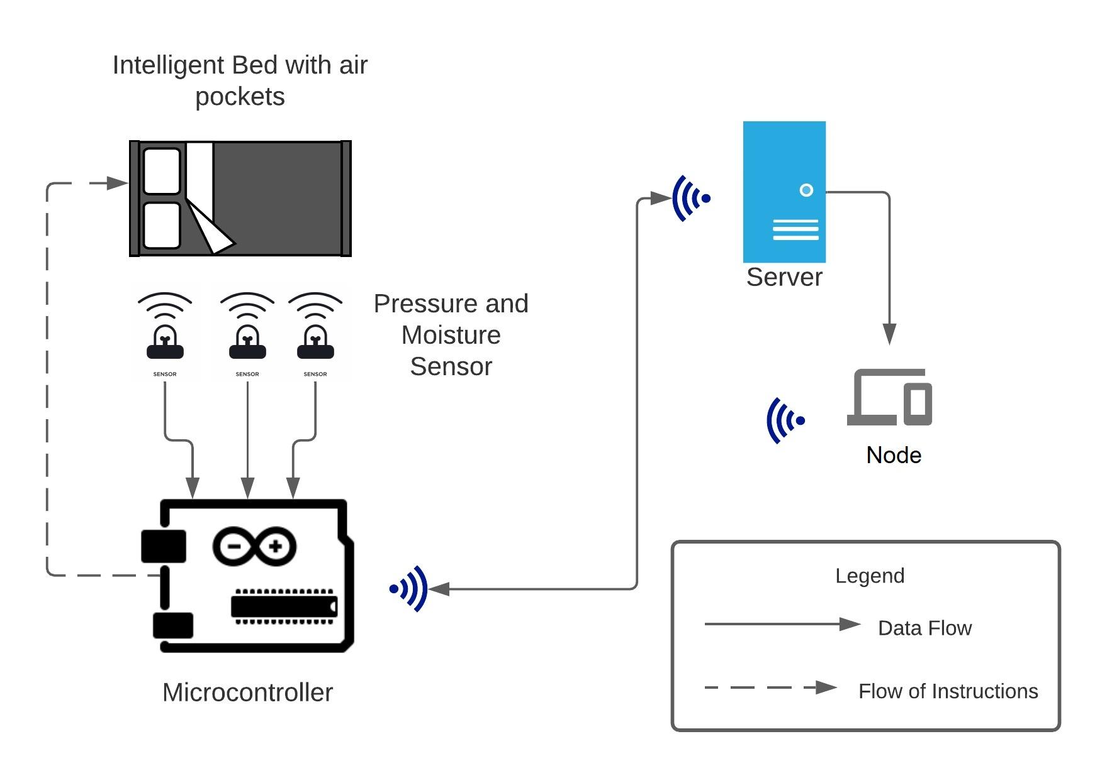

Fig Architecture Diagram

The process is as described:

1. The patient generates data pertaining to their physical conditions, ie., the moisture and temperature, and also pressure values.
2. These values are consolidated and analyzed
3. The results of the analysis are verified with baseline values and are checked if they are compliant or not
4. If compliant, then we re-run the loop
5. If the values do not comply with the baseline values, then the pressure at the at-risk areas are changed. Post changing, the values are checked again immediately for compliance
6. If compliant, then we re-run the loop
7. If the values do not comply, then the pressure is changed again

The solution we propose is divided into two parts: prevention and prediction. The prediction involves two factors: pressure and moisture. We propose monitoring the pressure values from the FlexiForce™ pressure sensor in real-time and comparing it against a set threshold value. If the threshold (400mm Hg) is crossed for a duration of time (4 to 6 hours), we take action that will be explained. For the moisture component, we measure the value via the moisture sensor, and using the data and the trained model, we predict the formation of a DU. The main goal of prevention is to reduce pressure and that can be done either by increasing the area of contact or decreasing the force on the body part. Moisture increases as the area of contact increases and so, the chances of a DU increase. We must consider moisture and pressure in preventing a DU.

Our solution for prevention involves a mattress that is fabricated with air pockets situated evenly across the mattress. These air pockets can be inflated and deflated using a microcontroller and a portable air pump, based on the real-time pressure sensor readings. The air pockets have a layer of cotton sheet over them, which is also connected to a pump to aerate humid areas and to make the mattress comfortable. The area of contact will have the air pockets deflated and the surrounding air pockets will be inflated. This will result in reduced pressure and increased aeration in the vulnerable area.

Body pressure distribution is constantly measured by the pressure sensors. Temperature and humidity are measured by using ambient temperature and humidity sensors. The inner pressure of each air cell is adjusted according to the site-specific body pressure data, temperature, and humidity. The pressure of the air cell is maintained by controlling the valves. The output valve is opened for a specified period to reduce the air pressure and the inlet valve is opened to increase the air pressure.

**2.2 System Requirement Specifications (Hardware & Software)**

The system requirements are as follows:

**Hardware Requirements**

* Arduino Uno R3
* SCX30ANC pressure sensor
* SEN-13322 moisture sensor
* NodeMCU ESP8266
* NW miniature air pump 5V-6VDC 400KPA 370

**Software Requirements**

* Notification Service
* Arduino IDE
* Browser
* Python
* Windows OS
* NodeJS

**Chapter 3**

**System Design**

**3.1 Architectural Design – Level 0 DFD**

The architectural design is as shown in the figure:

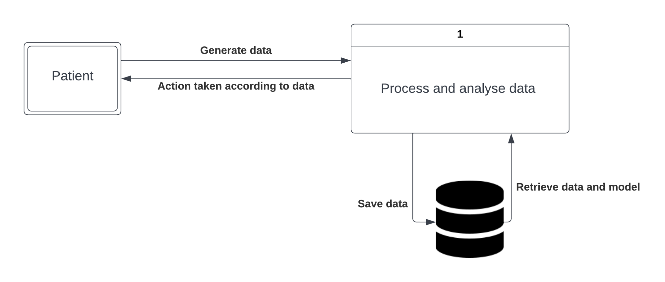

In the L0 Data Flow Diagram (DFD), we see that the patient generates the data relating to their physical condition and pressure values. Then this data is processed and analyzed internally, from which the data is saved at the data store and retrieved from it when required. According to the analysis results, the actions are taken by the system, which affects the patient directly.

**3.2 Component Design – Level 1 DFD**

The level 1 DFD for Voice recognition is as shown:

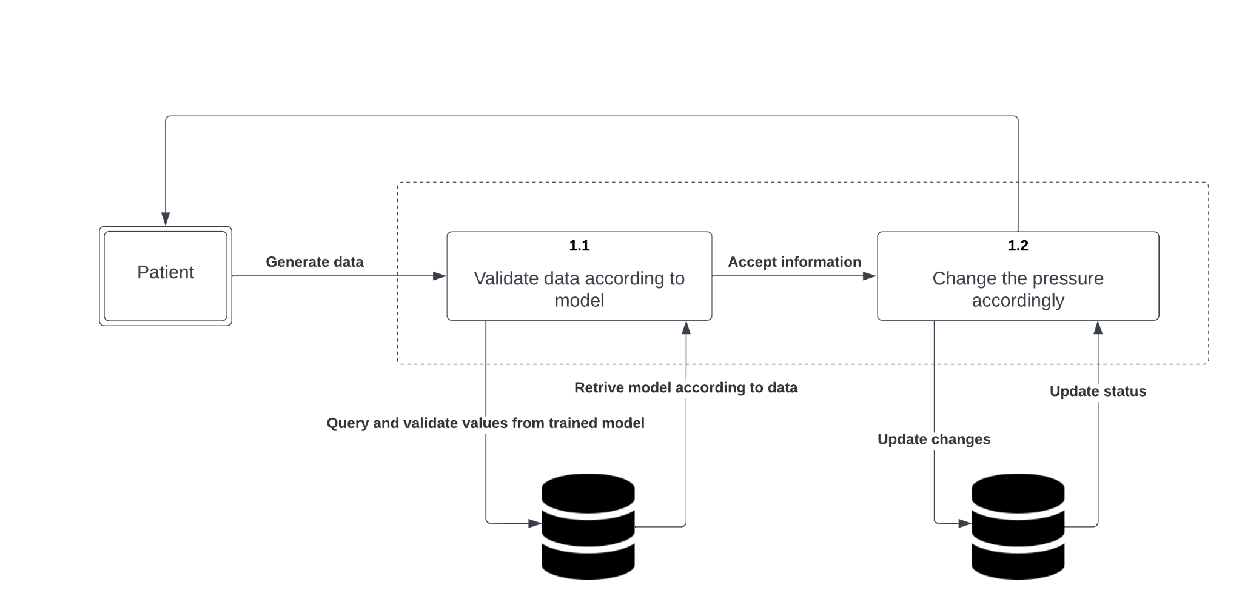

In the L1 Data Flow Diagram (DFD), we see that the patient generates the data relating to their physical condition and pressure values. This data is validated with the model trained via the data stored in the data store. Based on the validation, necessary changes in pressure are made. The changes are reflected in the data store and are further used to retrain the model when required.

**3.3 Behavioural Design**

The Sequence diagram for the system is as follows:

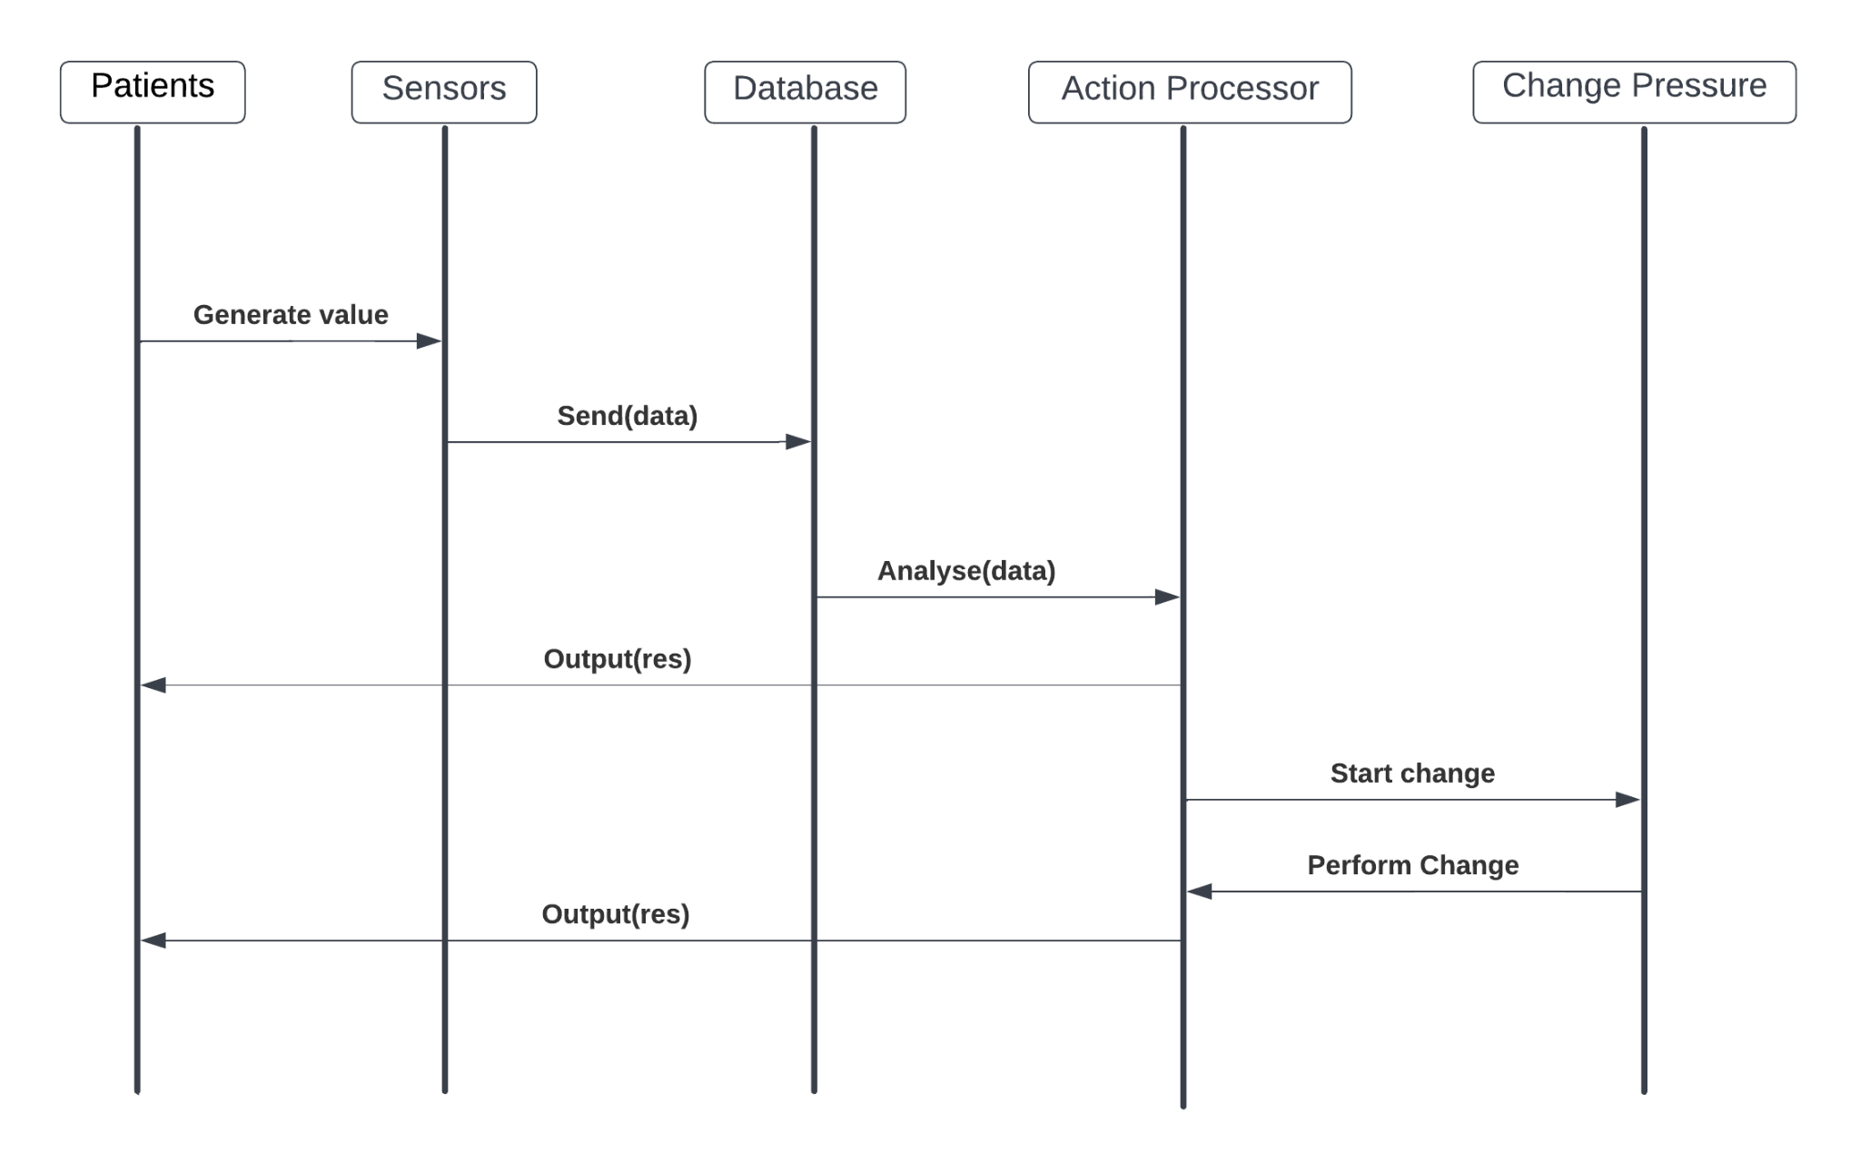

1. The patient generates values that are via sensor
2. The data is sent to the data store/database
3. The action processor receives data from the data store and analyses it
4. The results of the analysis are sent to the client as a response
5. According to the analysis, with the help of the trained NN model, pressure in the at-risk areas is changed
6. After the change is performed, the result/output is sent to the patient/client

**References**

# 

# [1] [N Bergstrom](https://pubmed.ncbi.nlm.nih.gov/?term=Bergstrom+N&cauthor_id=3299278), [B J Braden](https://pubmed.ncbi.nlm.nih.gov/?term=Braden+BJ&cauthor_id=3299278), [A Laguzza](https://pubmed.ncbi.nlm.nih.gov/?term=Laguzza+A&cauthor_id=3299278), [V Holman](https://pubmed.ncbi.nlm.nih.gov/?term=Holman+V&cauthor_id=3299278), The Braden Scale for Predicting Pressure Sore Risk: https://pubmed.ncbi.nlm.nih.gov/3299278/

[2] **Sam Mansfield.,Eric Vin.,Katia Obraczka(2021). An IoT System for Autonomous, Continuous, Real-Time Patient Monitoring and Its Application to Pressure Injury Management.** doi:[10.1109/ICDH52753.2021.00021](https://doi.org/10.1109/ICDH52753.2021.00021)

[3] **Functional textiles for prevention of pressure ulcers**

<https://www.emerald.com/insight/content/doi/10.1108/RJTA-10-2019-0047/full/html>

[4] [**Bilge Yilmaz**](https://ieeexplore.ieee.org/author/37086937469)**.,** [**Ercan Atagün**](https://ieeexplore.ieee.org/author/37085555621)**.,** [**Fadime ÖĞÜLMÜŞ Demırcan**](https://ieeexplore.ieee.org/author/37088979735)**.,** [**İbrahim Yücedağ**](https://ieeexplore.ieee.org/author/37085773171)**(2021). Classification of Pressure Ulcer Images with Logistic Regression.** doi:[10.1109/INISTA52262.2021.9548585](https://doi.org/10.1109/INISTA52262.2021.9548585)

[5] [**Therdpong Daengsi**](https://ieeexplore.ieee.org/author/38234558800)**.,**[**Bundit Muttisan**](https://ieeexplore.ieee.org/author/37088972879)**.,** [**Pongpisit Wuttidittachotti**](https://ieeexplore.ieee.org/author/37085384865)**.,** [**Patsita ., Sirawongphatsara**](https://ieeexplore.ieee.org/author/37085501633) **(2021). Sustainable Development of a Prototype of Air Mattress from Re-used Materials for Pressure Ulcer Prevention.** doi:[10.1109/GECOST52368.2021.9538773](https://doi.org/10.1109/GECOST52368.2021.9538773)

[6] [**Malindu Ehelagastenna**](https://ieeexplore.ieee.org/author/37088963383)**.,** [**Ishan Sumanasekara**](https://ieeexplore.ieee.org/author/37088964057)**.,** [**Hishan Wickramasinghe**](https://ieeexplore.ieee.org/author/37088964813)**.,** [**Indrajith D. Nissanka**](https://ieeexplore.ieee.org/author/37086962866)**.,** [**Gayani K. Nandasiri**](https://ieeexplore.ieee.org/author/37088965424)**(2021).Design of an Alternating Pressure Overlay for the Treatment of Pressure Ulcers.** doi:[10.1109/MERCon52712.2021.9525787](https://doi.org/10.1109/MERCon52712.2021.9525787)

[7] [**Eman Elsharif**](https://ieeexplore.ieee.org/author/37088904101)**.,** [**Nabil Drawil**](https://ieeexplore.ieee.org/author/37398909200)**., Salaheddine** [**Kanoun**](https://ieeexplore.ieee.org/author/37088903982)**(2021)Automatic Posture and Limb Detection for Pressure Ulcer Risk Assessment.** DOI: [10.1109/MI-STA52233.2021.9464360](https://doi.org/10.1109/MI-STA52233.2021.9464360)

[8] [**Zeinab Shayan**](https://ieeexplore.ieee.org/author/37086309025)**.,** [**Mohammad Sabouri**](https://ieeexplore.ieee.org/author/37086933950)**.,** [**Milad Shayan**](https://ieeexplore.ieee.org/author/37088841852)**.,** [**Mohammad Hassan Asemani**](https://ieeexplore.ieee.org/author/38467584900)**.,** [**Ali Bina Sarmoori**](https://ieeexplore.ieee.org/author/37088841101)**.,** [**Mohammad Zare**](https://ieeexplore.ieee.org/author/37088841274)**(2021). Pressure control of cellular electromechanical medical mattresses for bedsore prevention.** DOI: [10.1109/ICCIA52082.2021.9403585](https://doi.org/10.1109/ICCIA52082.2021.9403585)

[9] [**Eun-Bin Park**](https://ieeexplore.ieee.org/author/37088643518)**.,**[**Jin-Chul Heo**](https://ieeexplore.ieee.org/author/37088641214)**.,** [**Chanil Kim**](https://ieeexplore.ieee.org/author/37422430600)**.,** [**Beomjoon Kim**](https://ieeexplore.ieee.org/author/37088644852)**.,** [**Kwangyeol Yoon**](https://ieeexplore.ieee.org/author/37088643699)**.,** [**Jong-Ha Lee**](https://ieeexplore.ieee.org/author/38566958400)**(2020).Development of a Patch-Type Sensor for Skin Using Laser Irradiation Based on Tissue Impedance for Diagnosis and Treatment of Pressure Ulcer.** DOI: [10.1109/ACCESS.2020.3048242](https://doi.org/10.1109/ACCESS.2020.3048242)

[10] **Kottner, J., Cuddigan, J., Carville, K., Balzer, K., Berlowitz, D., Law, S., … Haesler, E. (2020). Pressure ulcer/injury classification today: An international perspective. Journal of Tissue Viability.** doi:10.1016/j.jtv.2020.04.003

[11] [**Brecht Serraes**](https://onlinelibrary.wiley.com/action/doSearch?ContribAuthorRaw=Serraes%2C+Brecht)**,**[**Martin van Leen**](https://onlinelibrary.wiley.com/action/doSearch?ContribAuthorRaw=van+Leen%2C+Martin)**,**[**Jos Schols**](https://onlinelibrary.wiley.com/action/doSearch?ContribAuthorRaw=Schols%2C+Jos)**,**[**Ann Van Hecke**](https://onlinelibrary.wiley.com/action/doSearch?ContribAuthorRaw=van+Hecke%2C+Ann)**,**[**Sofie Verhaeghe**](https://onlinelibrary.wiley.com/action/doSearch?ContribAuthorRaw=Verhaeghe%2C+Sofie)**,**[**Dimitri Beeckman**](https://onlinelibrary.wiley.com/action/doSearch?ContribAuthorRaw=Beeckman%2C+Dimitri)**(2018). Prevention of pressure ulcers with a static air support surface: A systematic review**. [doi.org/10.1111/iwj.12870](https://doi.org/10.1111/iwj.12870)